Nathan Hanuscin

CPE301 – SPRING 2018

Design Assignment 2

**DO NOT REMOVE THIS PAGE DURING SUBMISSION:**

The student understands that all required components should be submitted in complete for grading of this assignment.

|  |  |  |  |
| --- | --- | --- | --- |
| **NO** | **SUBMISSION ITEM** | **COMPLETED (Y/N)** | **MARKS**  **(/MAX)** |
| 1 | COMPONENTS LIST AND CONNECTION BLOCK DIAGRAM w/ PINS |  |  |
| 2. | INITIAL CODE OF TASK 1/A |  |  |
| 3. | INCREMENTAL / DIFFERENTIAL CODE OF TASK 2/B |  |  |
| 3. | INCREMENTAL / DIFFERENTIAL CODE OF TASK 3/C |  |  |
| 3. | INCREMENTAL / DIFFERENTIAL CODE OF TASK 4/D |  |  |
| 3. | INCREMENTAL / DIFFERENTIAL CODE OF TASK 5/E |  |  |
| 4. | SCHEMATICS |  |  |
| 5. | SCREENSHOTS OF EACH TASK OUTPUT |  |  |
| 5. | SCREENSHOT OF EACH DEMO |  |  |
| 6. | VIDEO LINKS OF EACH DEMO |  |  |
| 7. | GOOGLECODE LINK OF THE DA |  |  |
|  |  |  |  |
|  |  |  |  |

1. **COMPONENTS LIST AND CONNECTION BLOCK DIAGRAM w/ PINS**

One 220Ω resistor

Two 10KΩ resistors

One pushbutton

One red LED

(See schematics for diagrams)

1. **INITIAL/DEVELOPED CODE OF TASK 1/A**

No initial code for any tasks.

1. **MODIFIED CODE OF TASK 1/A**

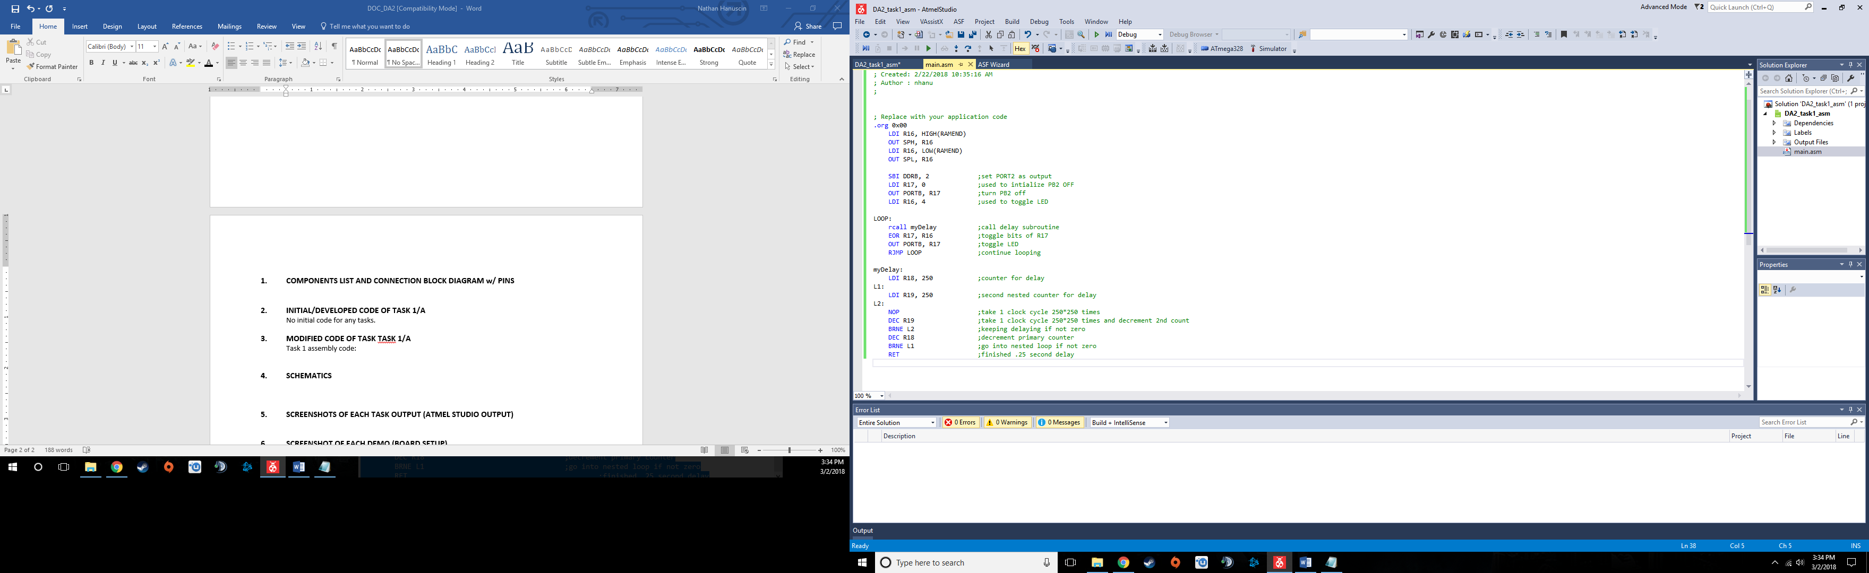Task 1 assembly code:

Task 1 C code:

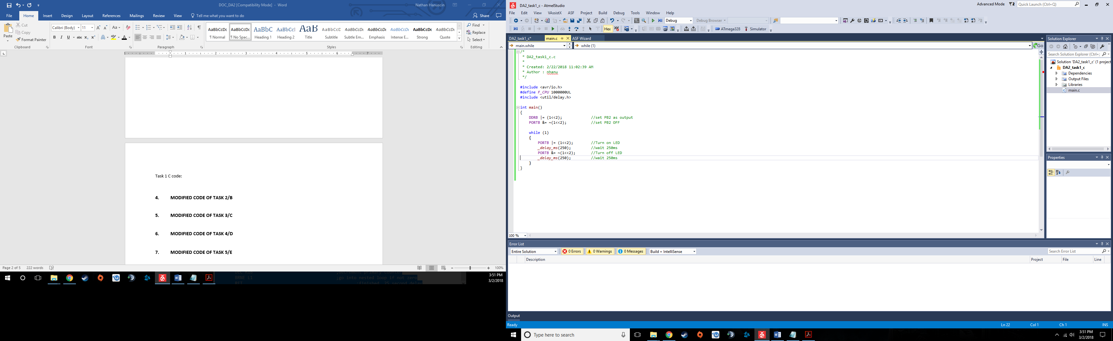

**4. MODIFIED CODE OF TASK 2/B**

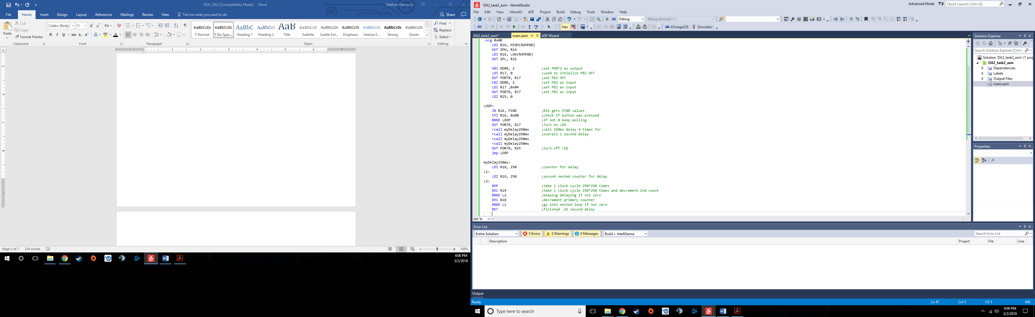Task 2/B assembly code:

Task 2/B C code:

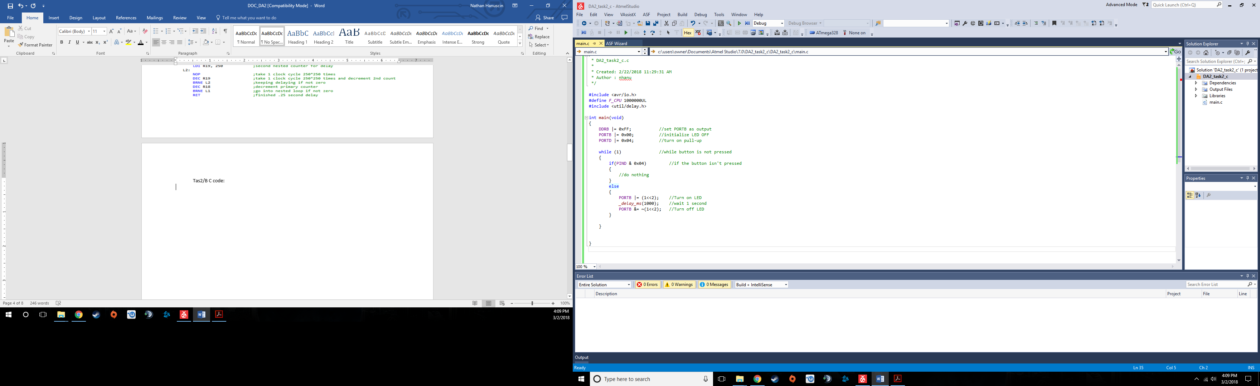

**5. MODIFIED CODE OF TASK 3/C**

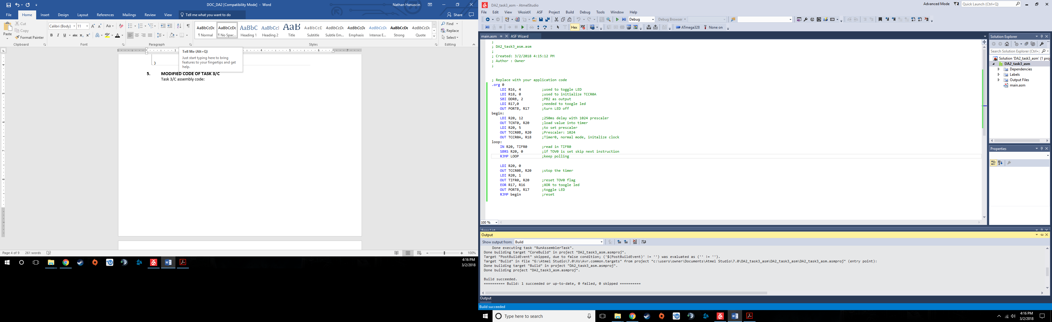Task 3/C assembly code:

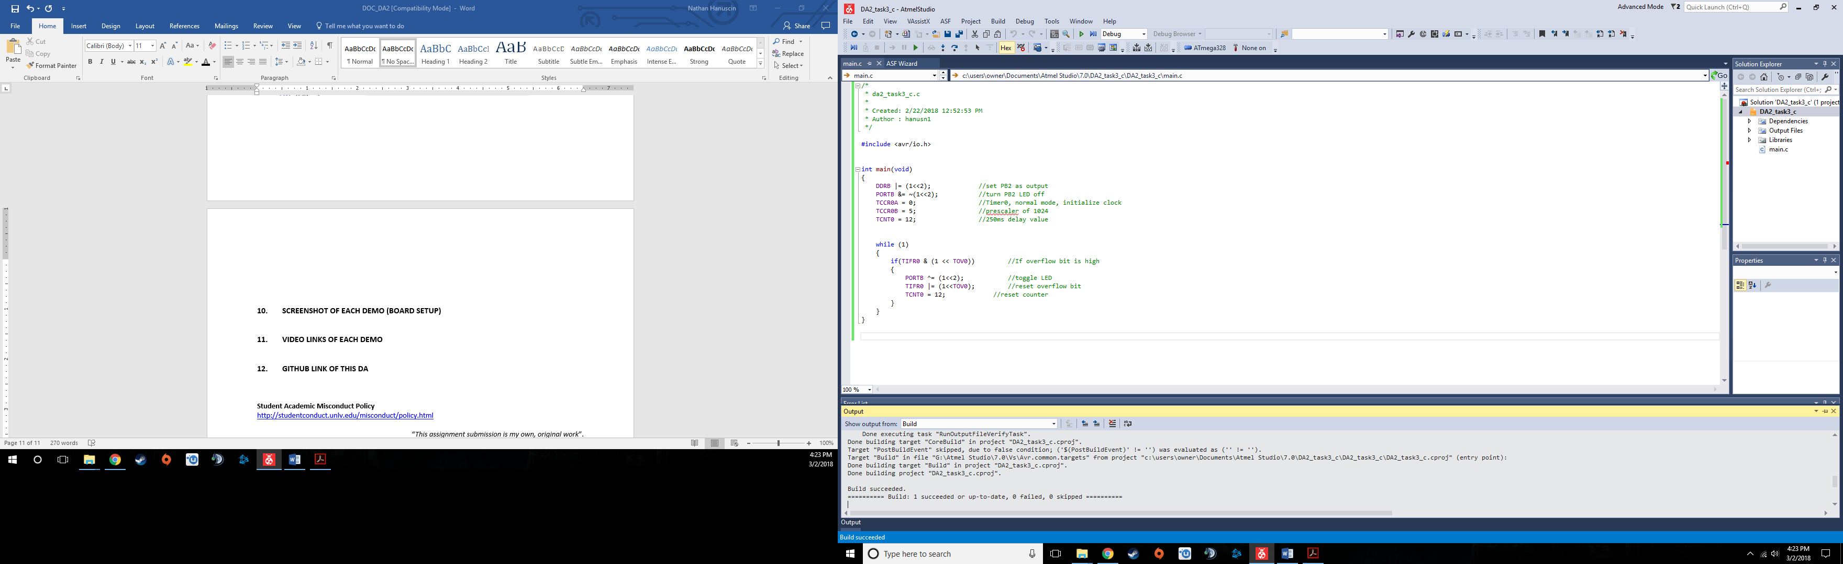Task 3/C C code:

**6. MODIFIED CODE OF TASK 4/D**

Task 4/D assembly code:

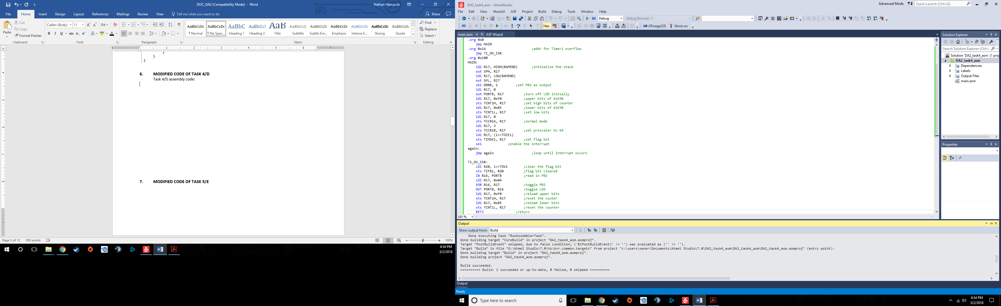

Task 4/D C code:

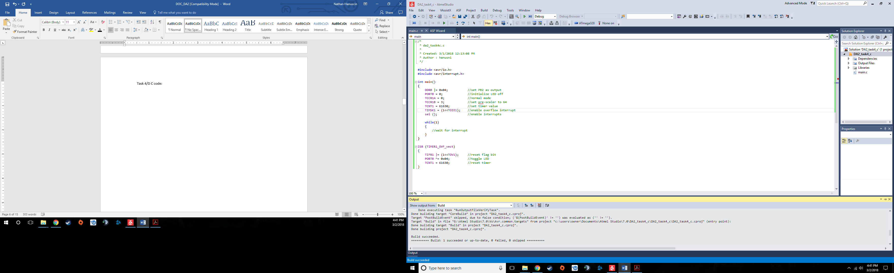

**7. MODIFIED CODE OF TASK 5/E**

Task 5/E assembly code:

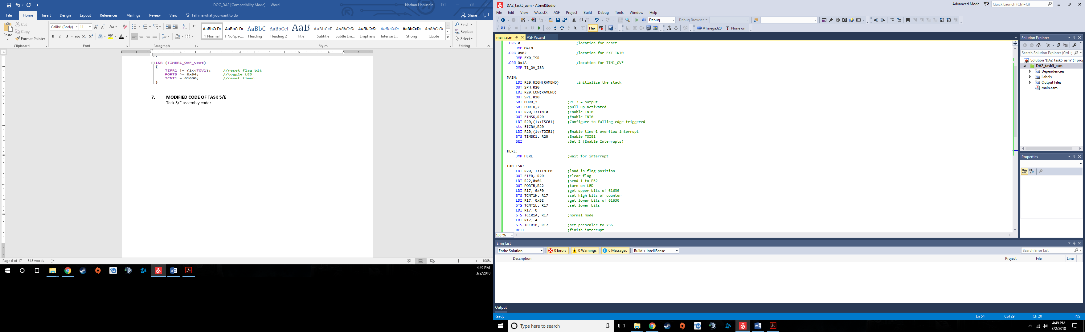

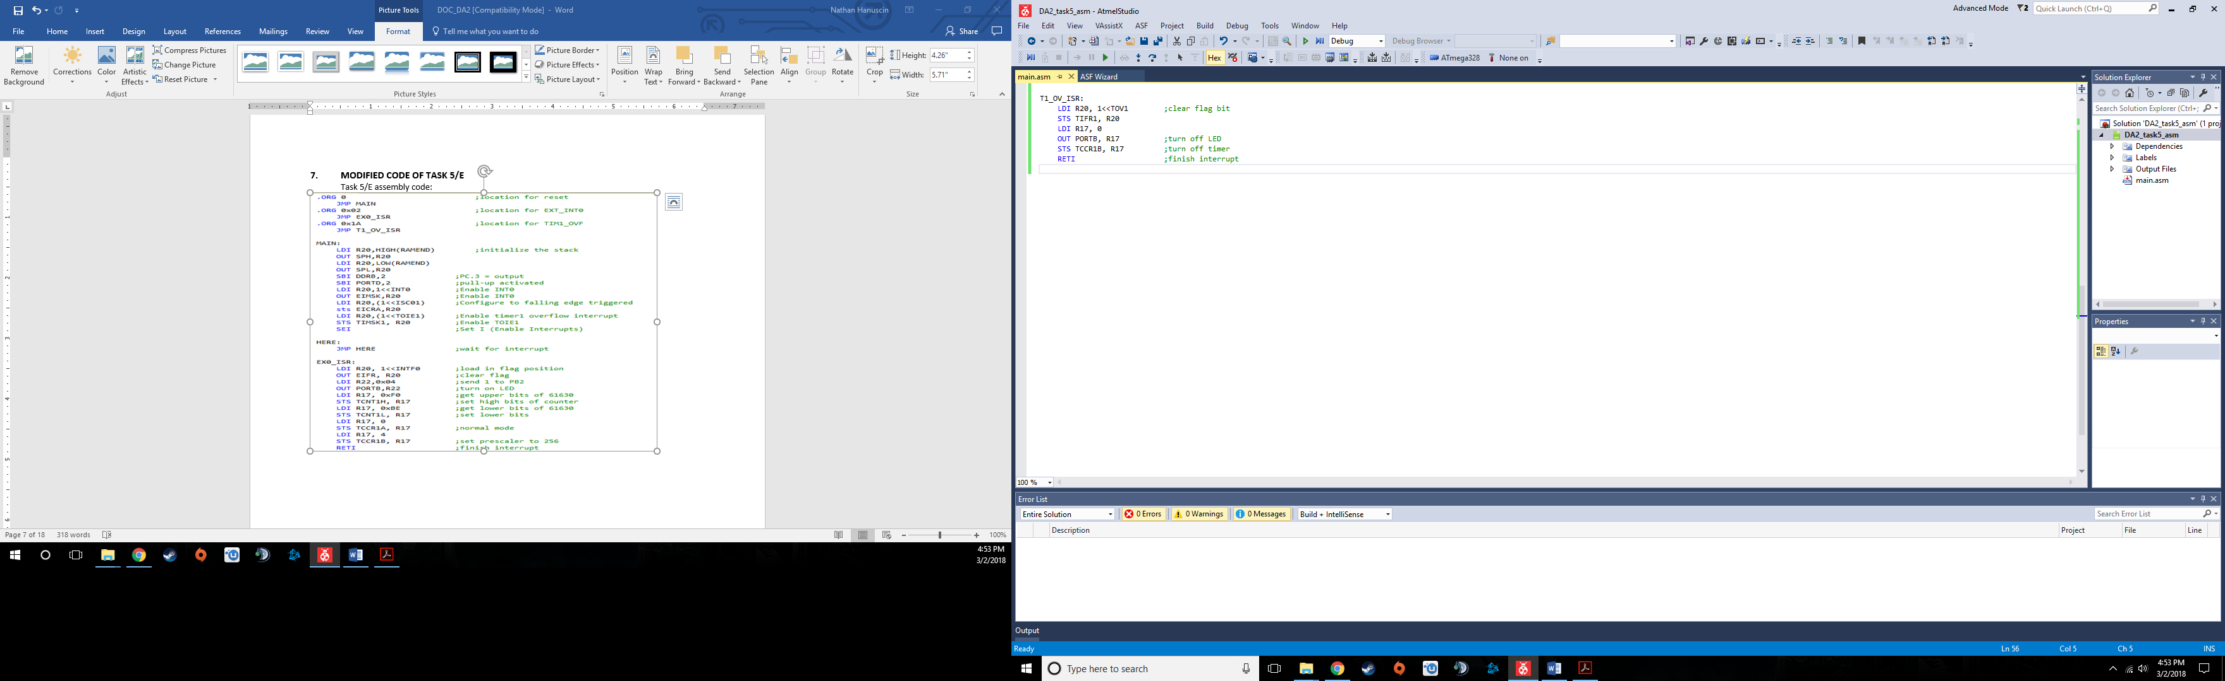

Task 5/E C code:

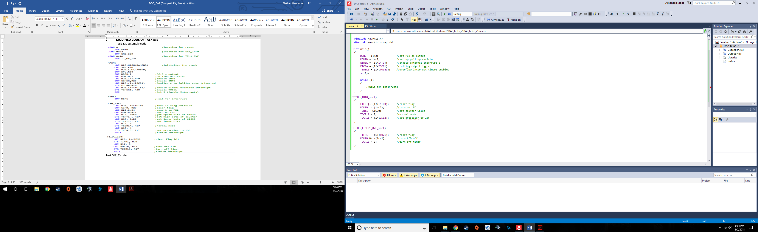

1. **SCHEMATICS**

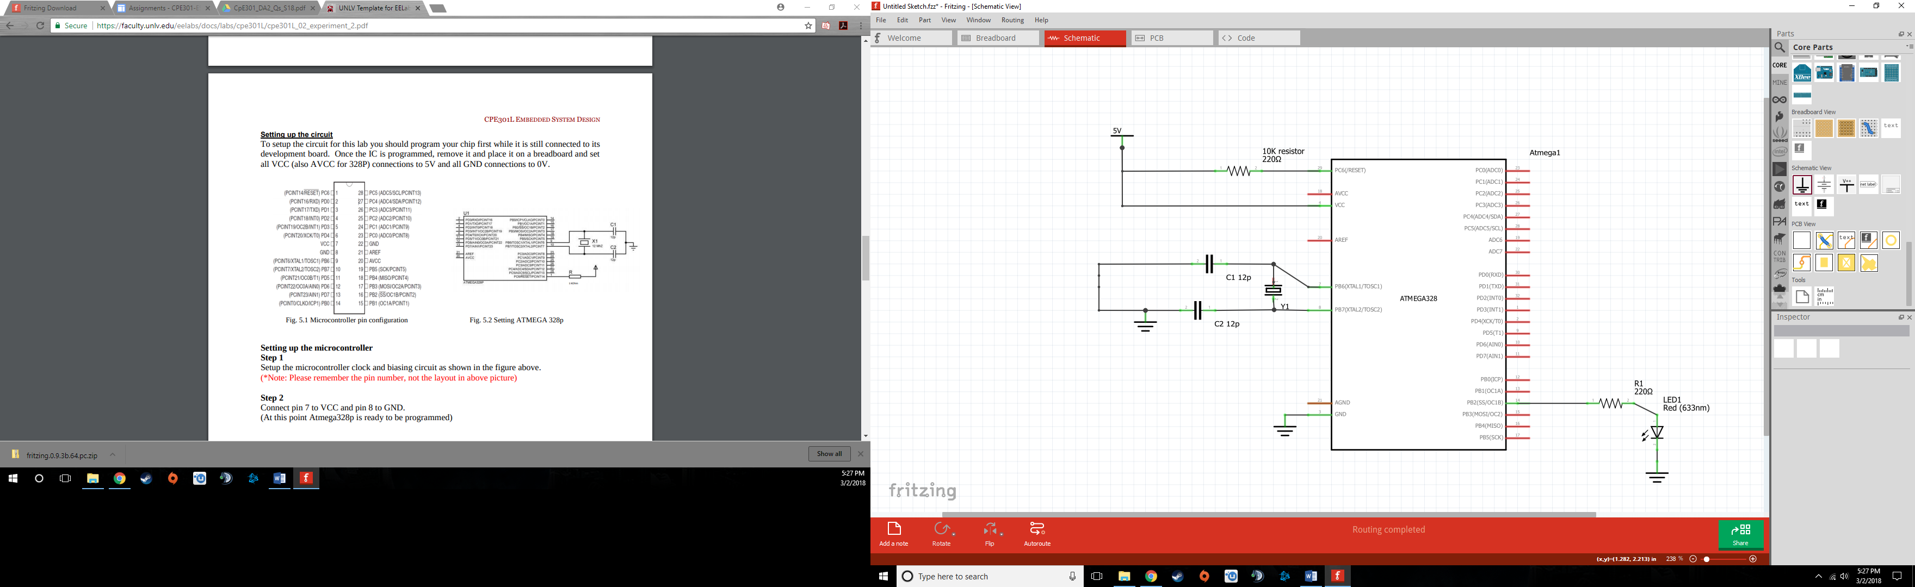Schematic for tasks 1,3, and 4

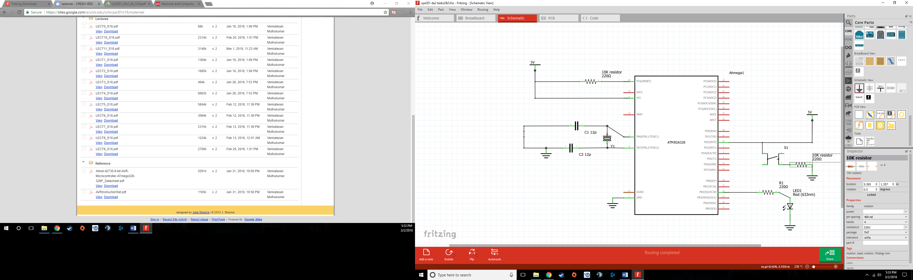Schematic for tasks 2 and 5

1. **SCREENSHOTS OF EACH TASK OUTPUT (ATMEL STUDIO OUTPUT)**

Task 1/A assembly before delay:

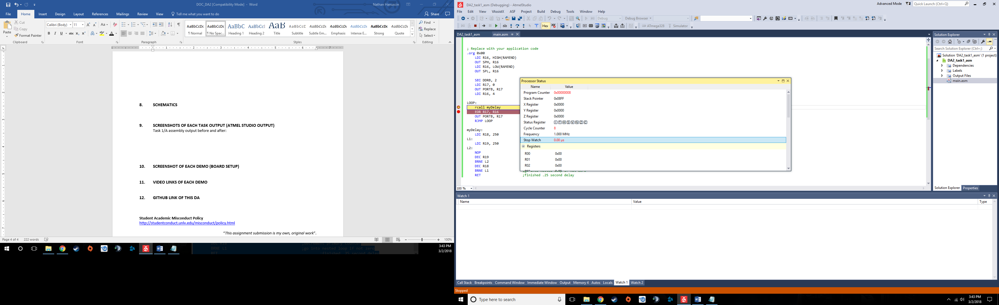

After delay:

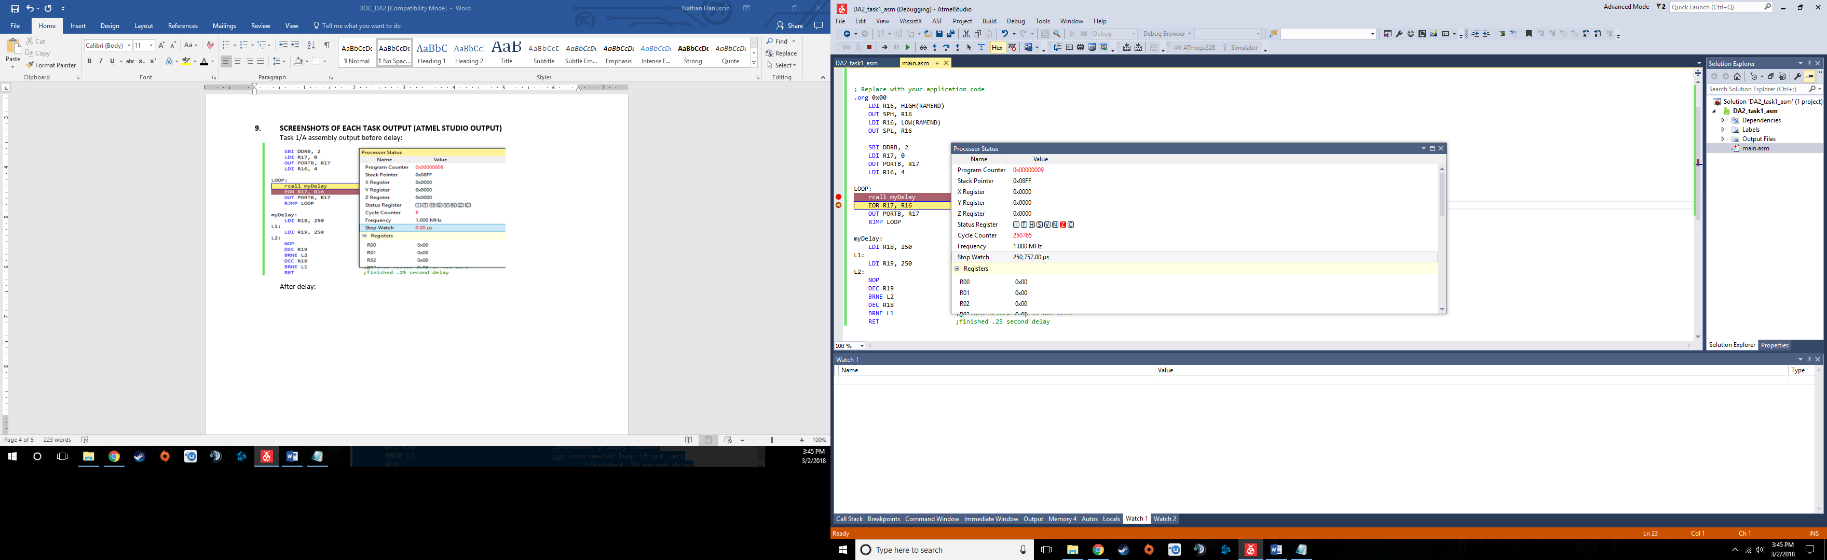

Task 1/A C code before delay:

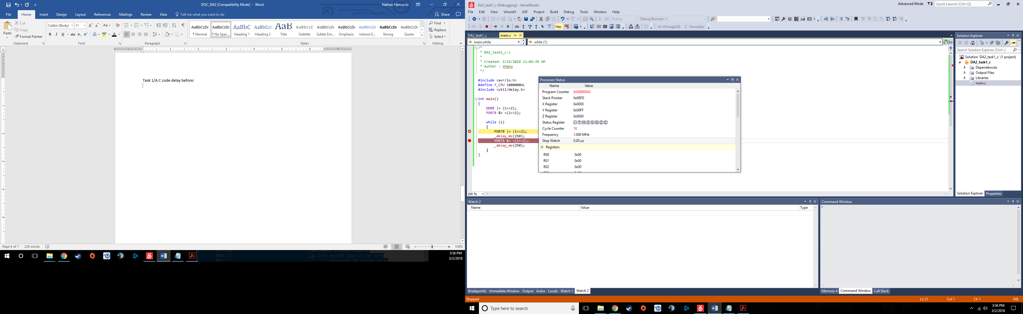

After delay:

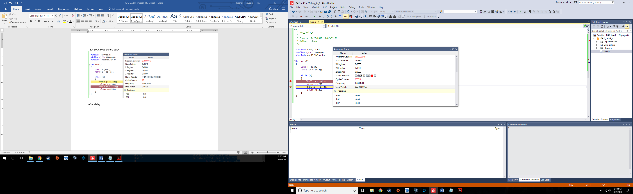

Task 2/B assembly before button pushed:

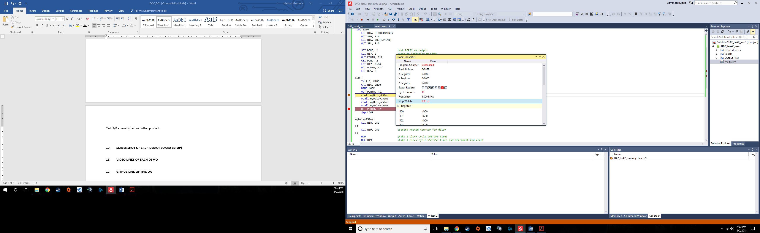

After button pushed:

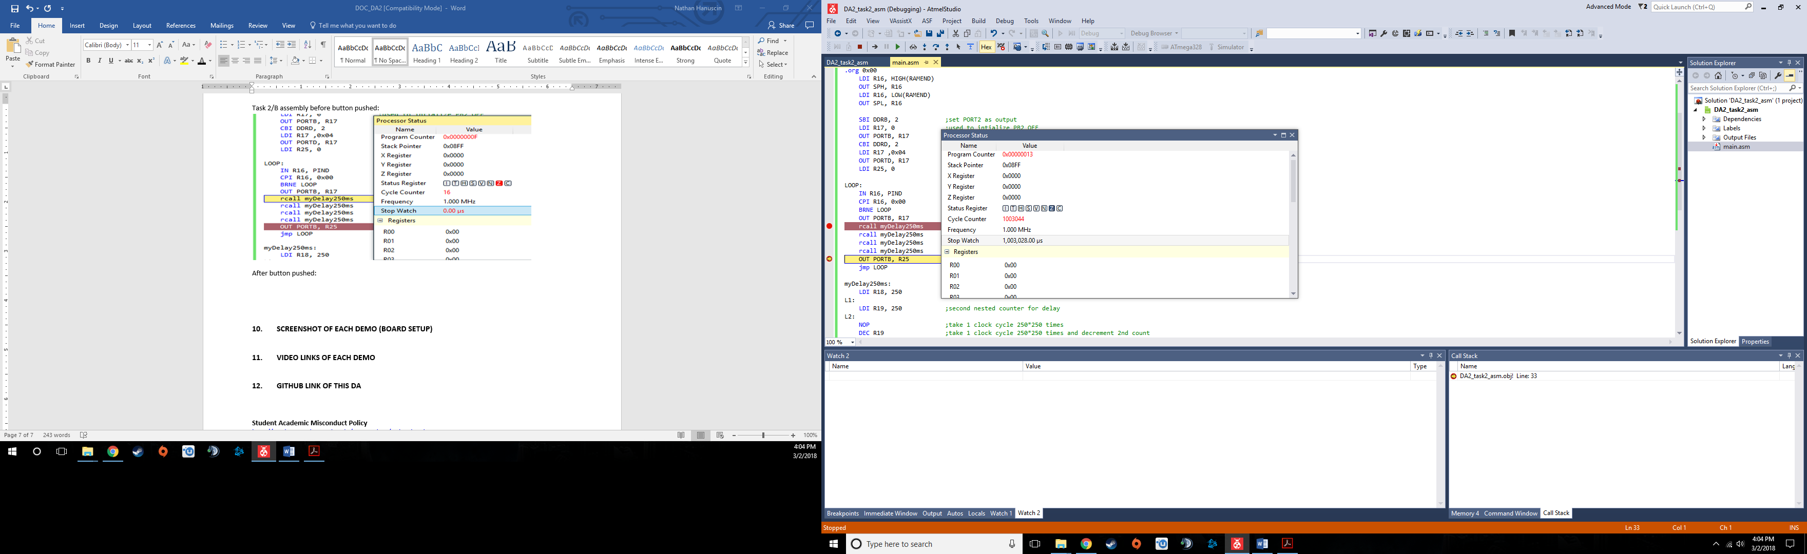

Task 2/B C code before button pushed:

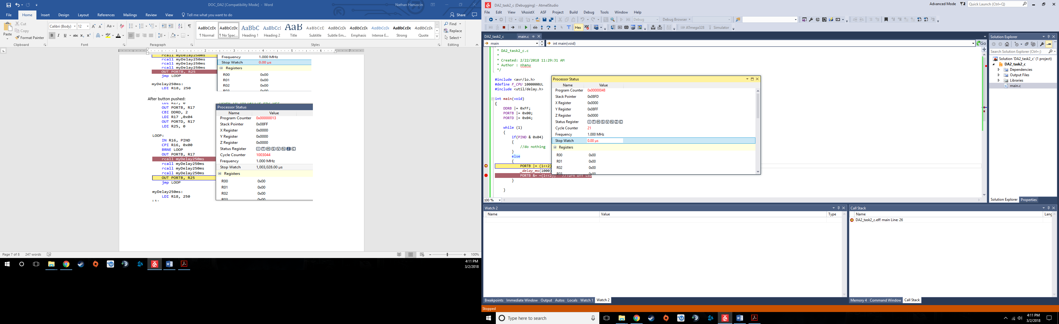

After button pushed:

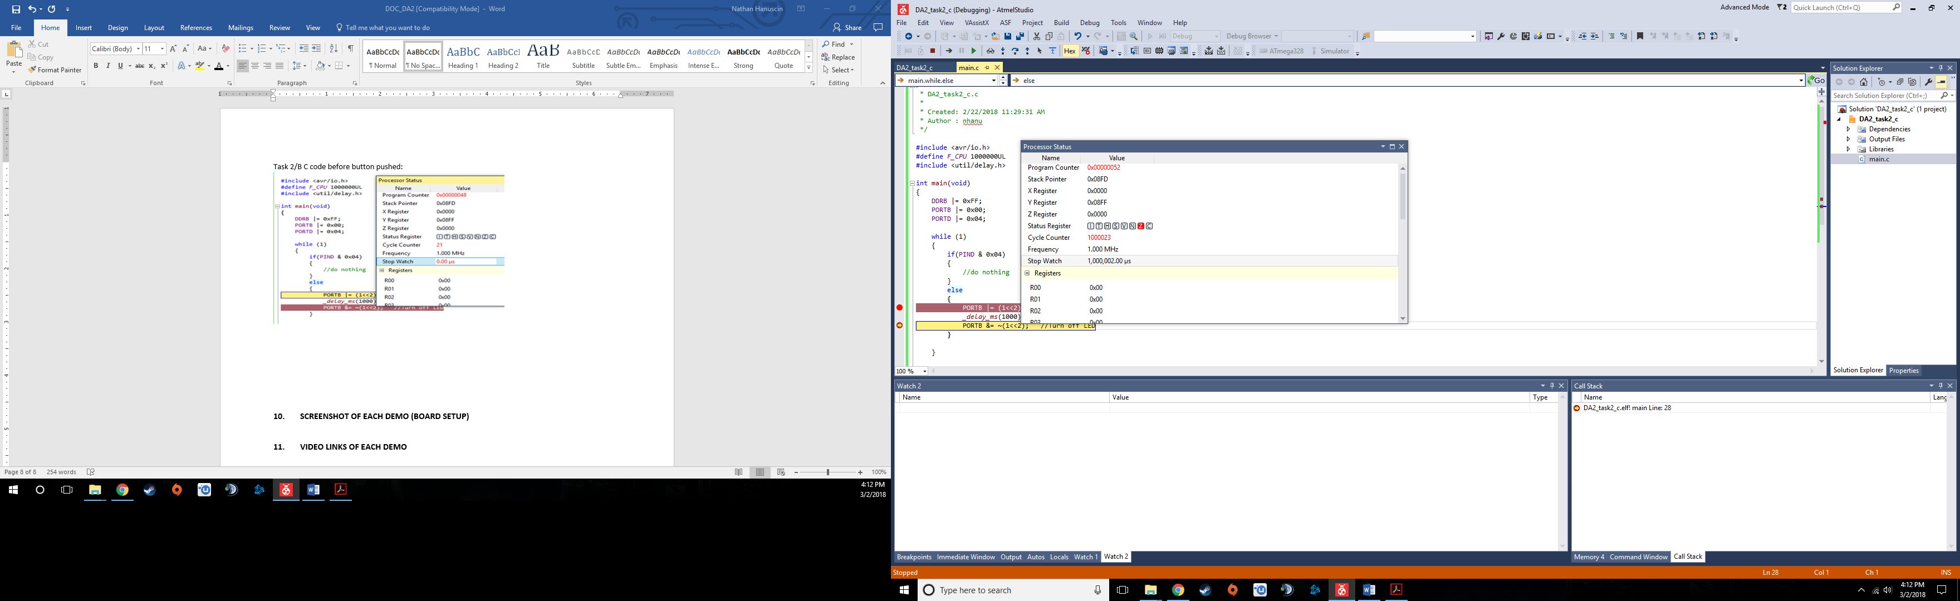

Task 3/C assembly before timer overflow:

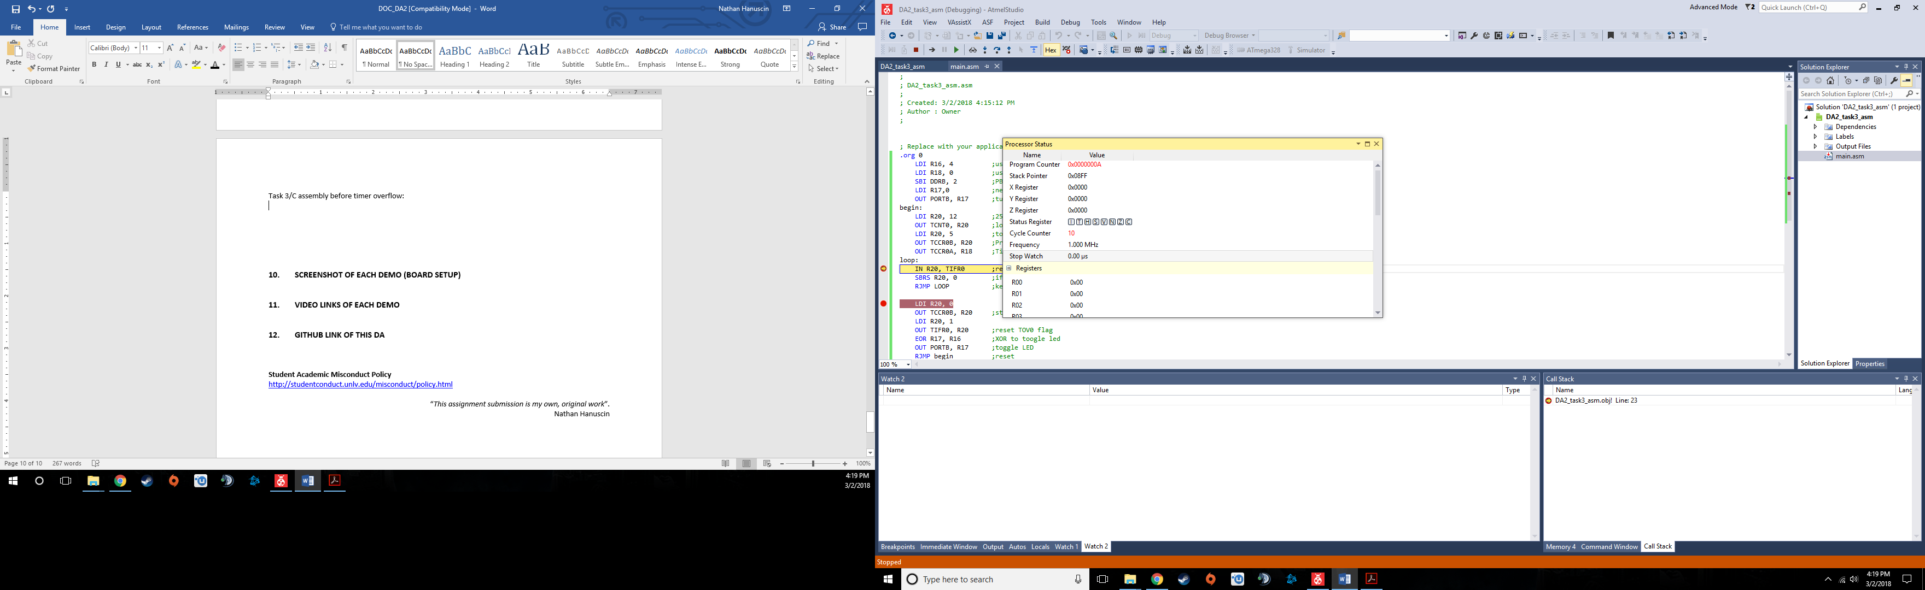

After timer overflow:

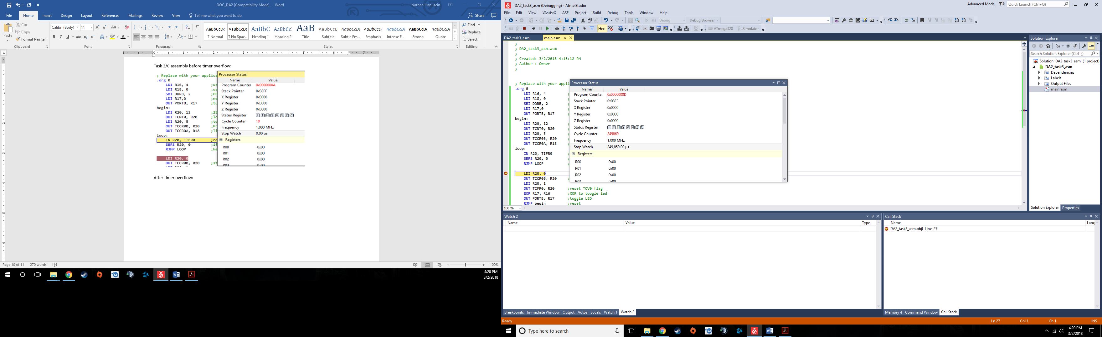

Task 3/C C code before timer overflow:

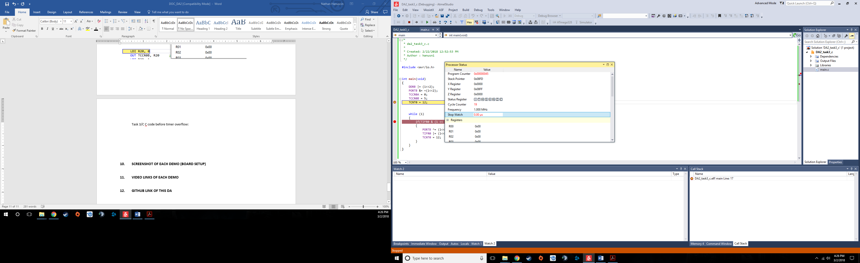

After timer overflow:

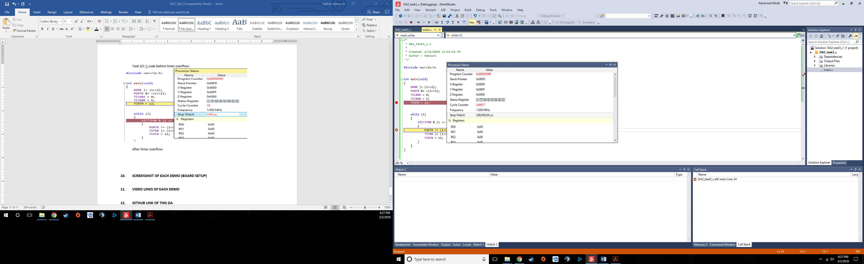

Task 4/D assembly code before timer interrupt overflow:

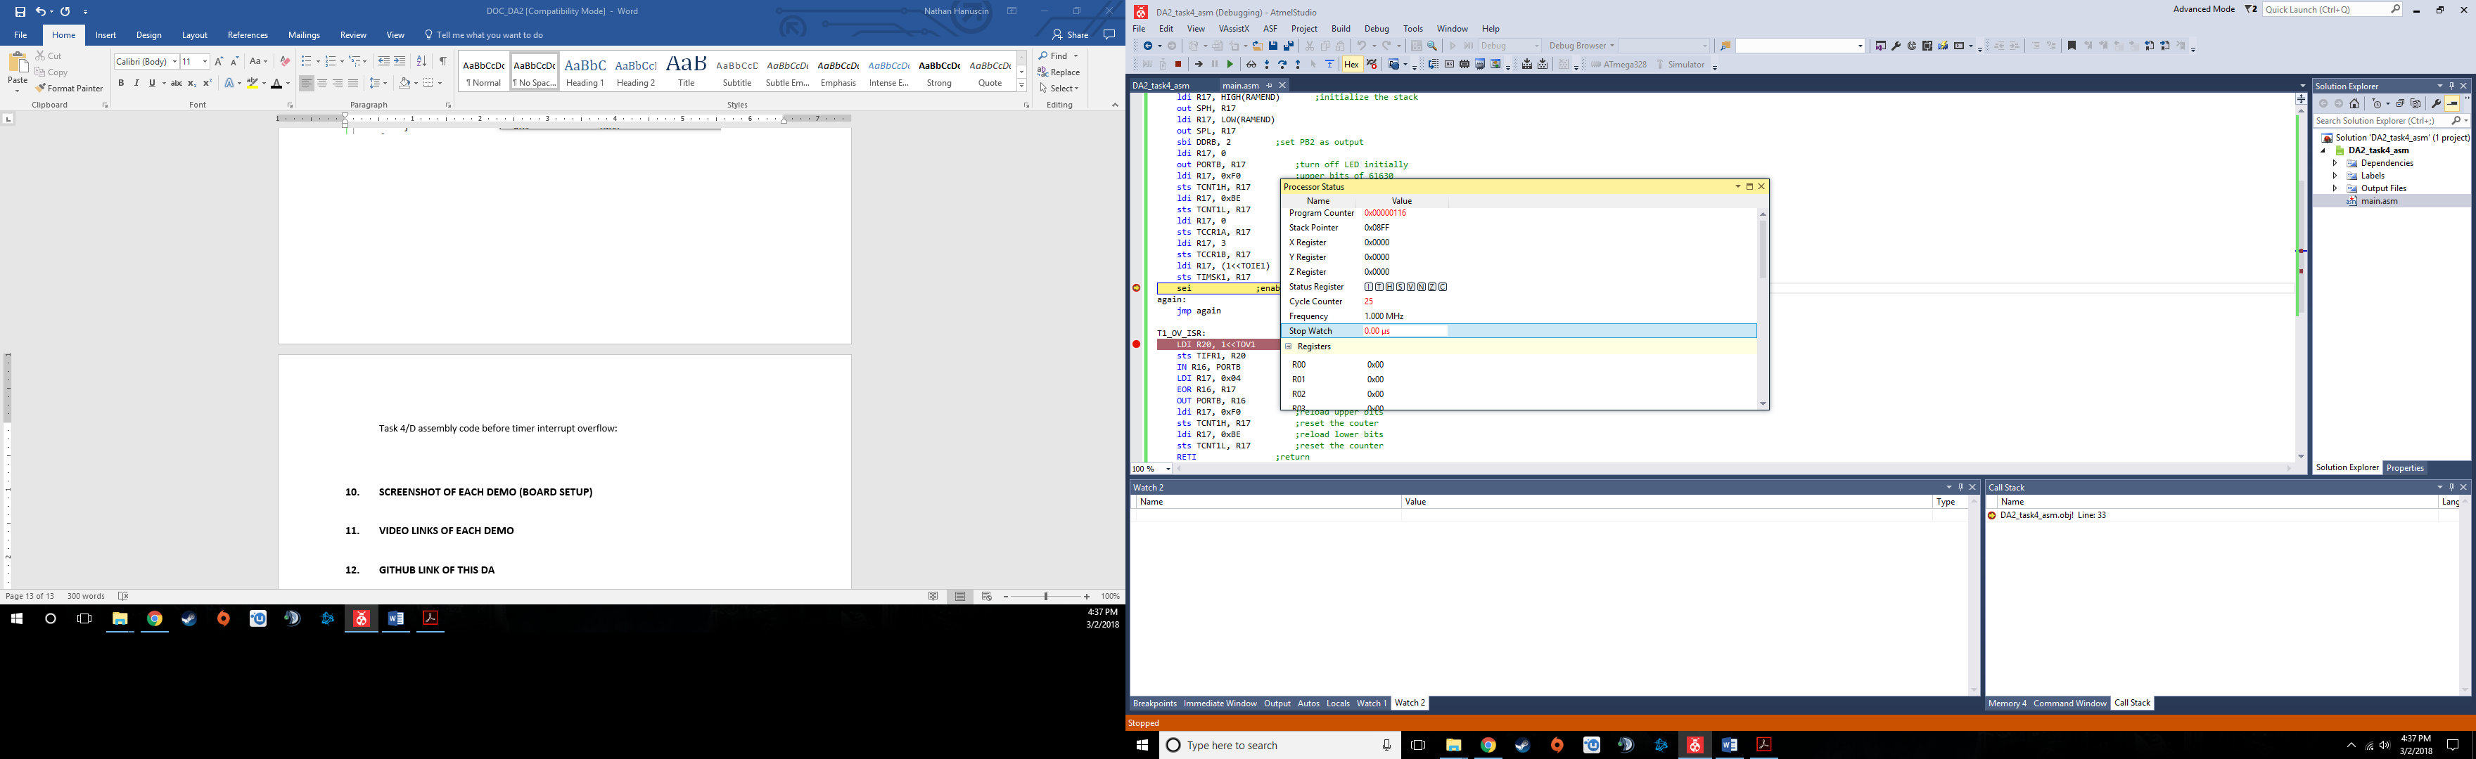

After interrupt occurs:

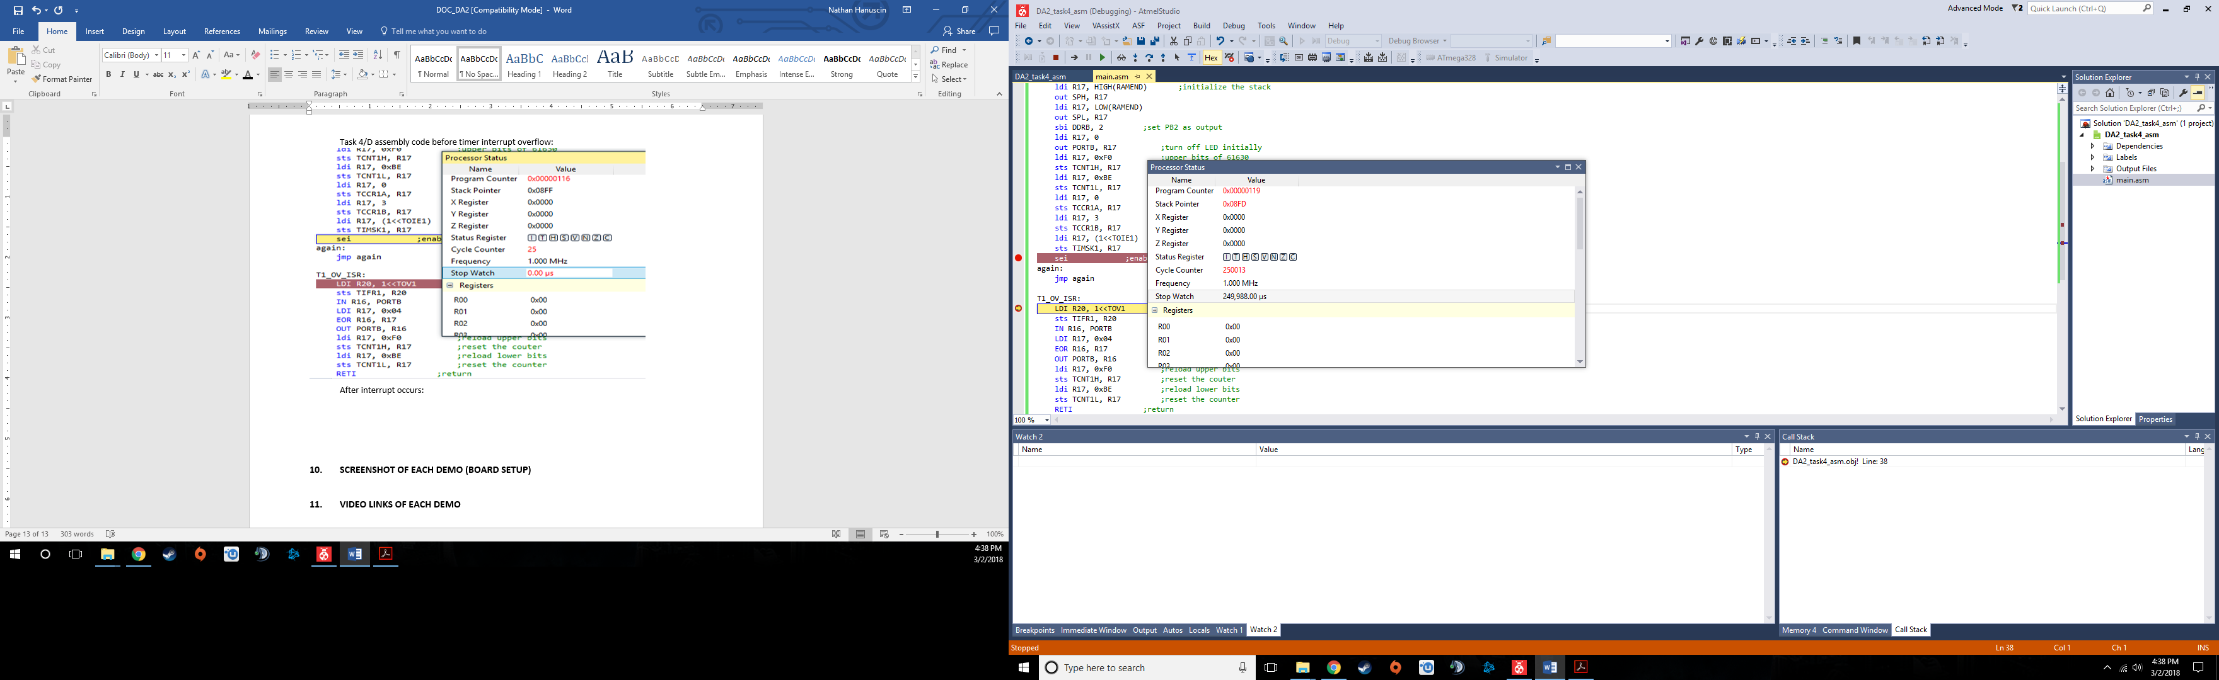

Task 4/D C code before timer overflow interrupt:

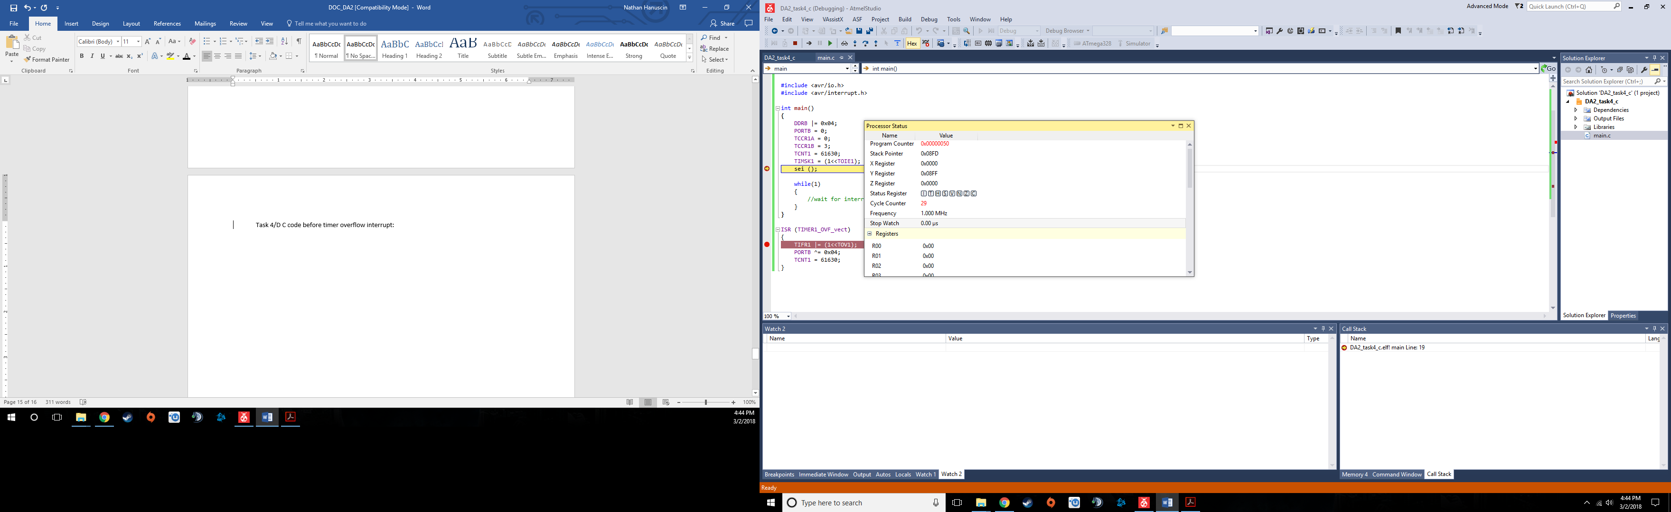

After interrupt occurs:

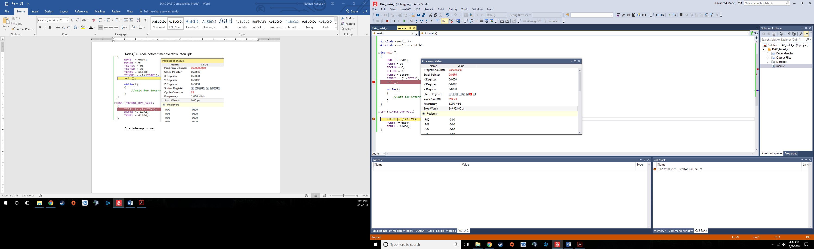

Task 5/E assembly before timer interrupt:

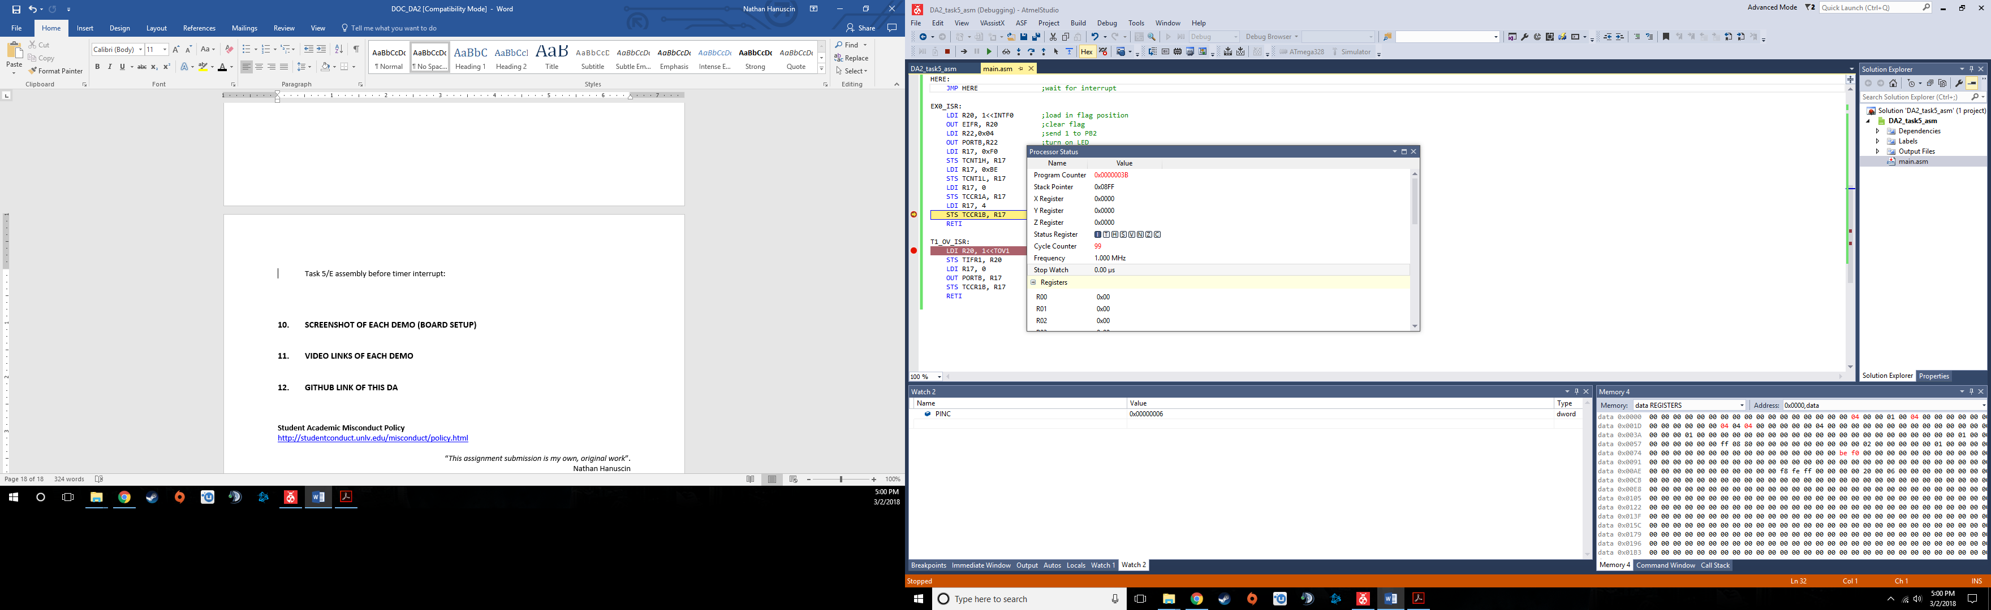

After interrupt:

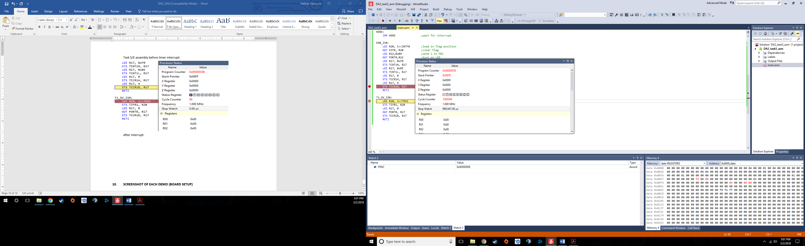

Task 5/E before timer interrupt:

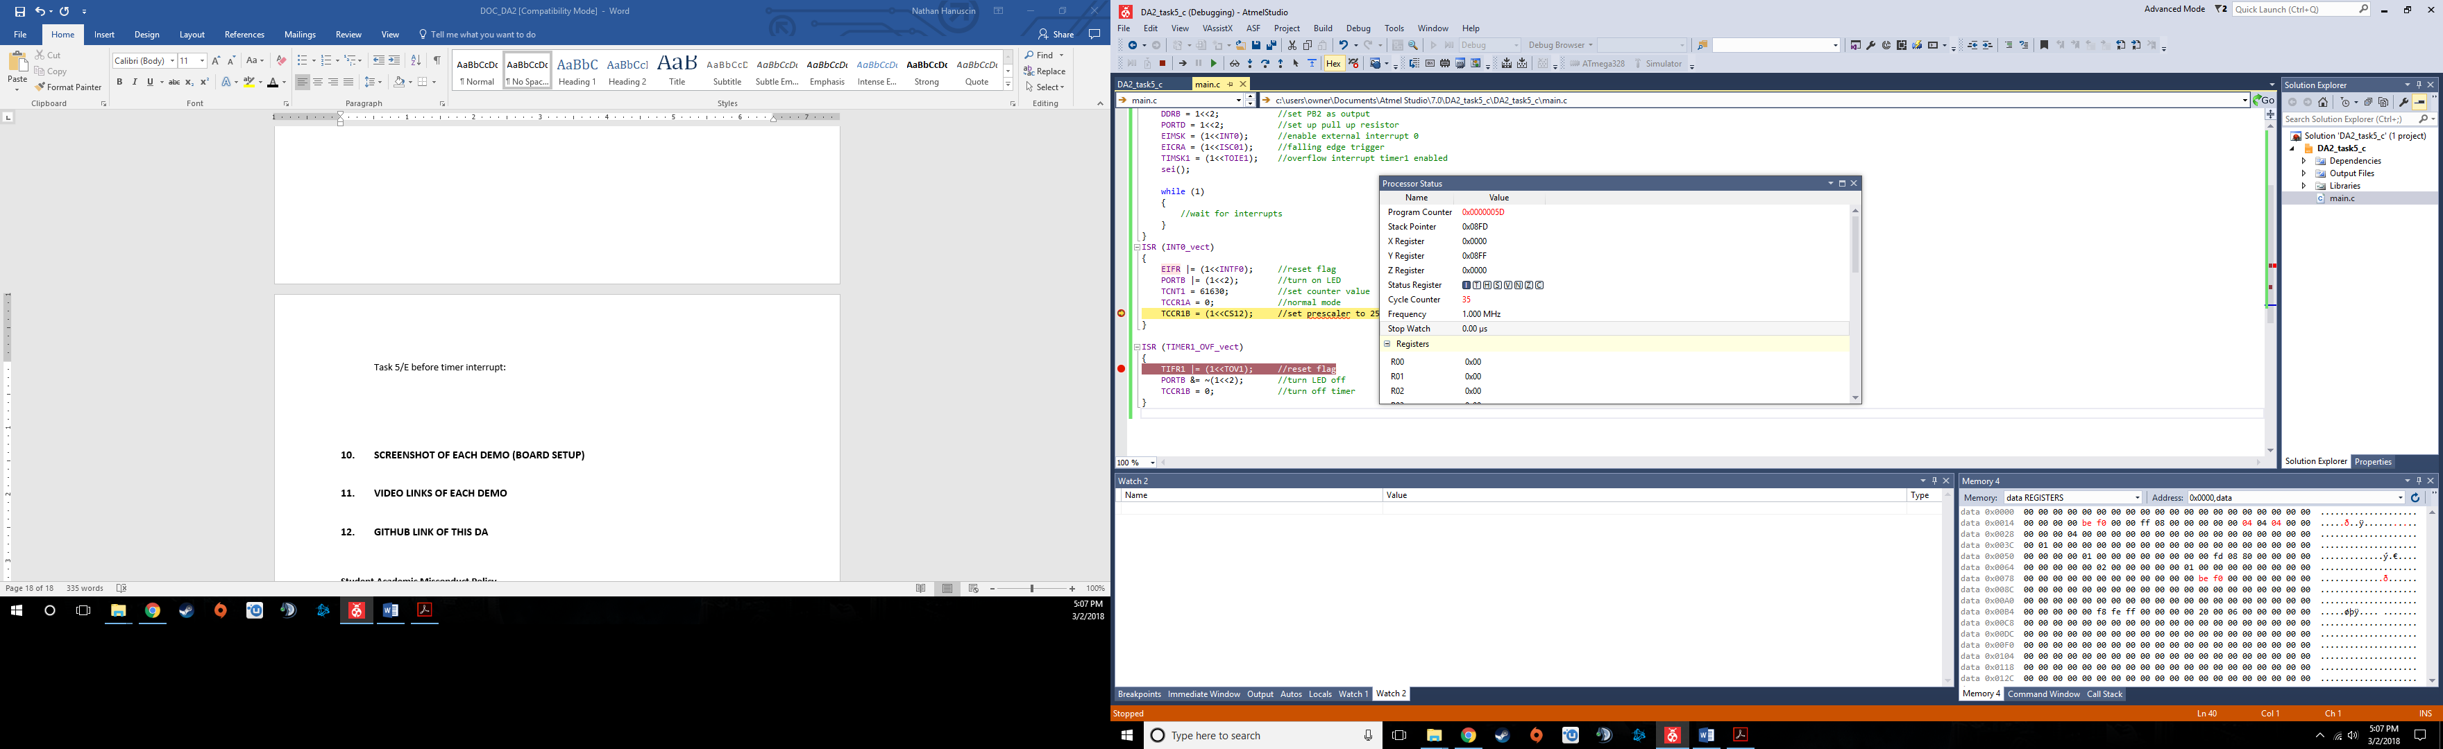

After interrupt:

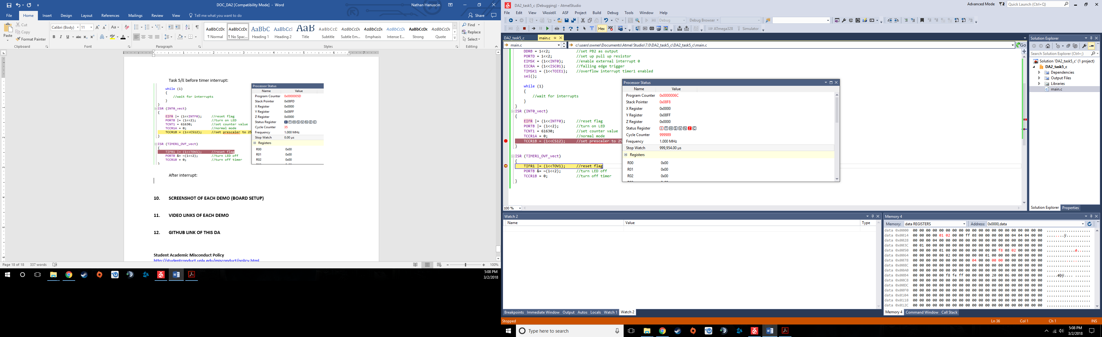

1. **SCREENSHOT OF EACH DEMO (BOARD SETUP)**

Setup for tasks 1, 3, and 4

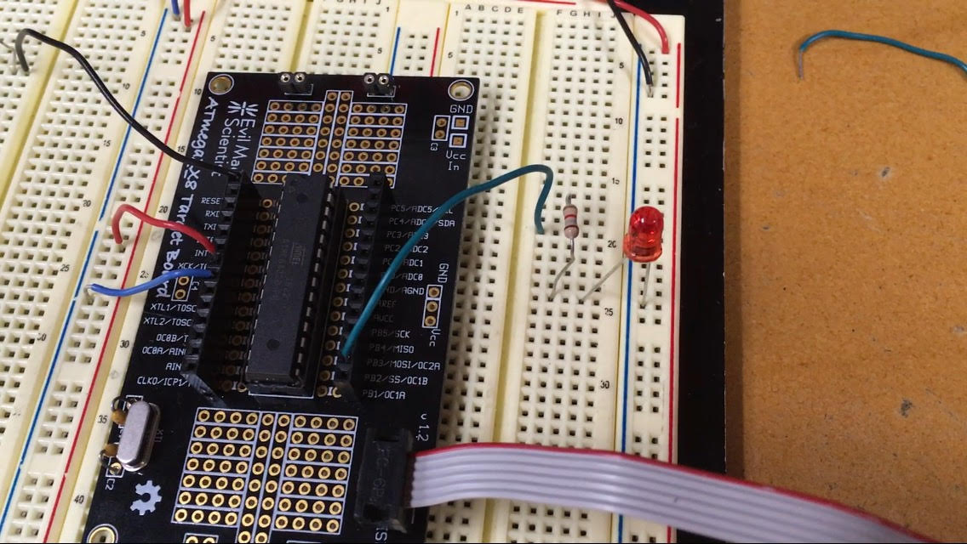

Set up for tasks 2 and 5

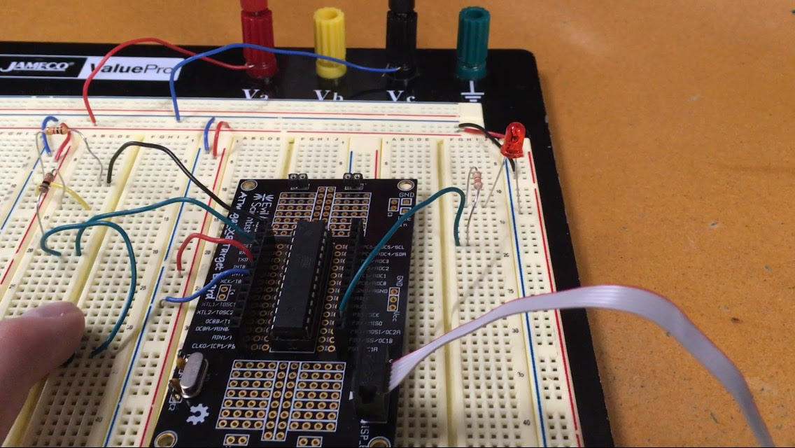

1. **VIDEO LINKS OF EACH DEMO**

Tasks 1/3/4 - https://www.youtube.com/watch?v=Q2s7c8BWkkk

Tasks 2/5 - https://www.youtube.com/watch?v=0_fHTzq70SA

1. **GITHUB LINK OF THIS DA**

https://github.com/nhanuscin/submit/tree/master/DA2

**Student Academic Misconduct Policy**

<http://studentconduct.unlv.edu/misconduct/policy.html>

“This assignment submission is my own, original work”.

Nathan Hanuscin